02/15/2024

Dear Parents and Community Members:

We are pleased to present you with the Annual Education Report (AER), which provides key information on the 2022-23 educational progress for Discovery Creative Pathways – Harper Woods. The AER addresses the complex reporting information required by federal and state laws. The school’s report contains information about student assessment, accountability, and teacher quality. If you have any questions about the AER, please contact Erika Dietz for assistance.

The AER is available for you to review electronically by visiting the following website, https://www.mischooldata.org/annual-education-report-1?Common_Locations=1-S,16097,2956,119 or you may review a copy in the main office at your child’s school.

For the 2023-24 school year, schools were identified based on previous years’ performance using definitions and labels as required in the Every Student Succeeds Act (ESSA). A Targeted Support and Improvement (TSI) school is one that had at least one underperforming student subgroup in 2022-23. An Additional Targeted Support (ATS) school is one that had a student subgroup performing at the same level as the lowest 5% of all schools in the state in 2021-22. A Comprehensive Support and Improvement (CSI) school is one whose performance was in the lowest 5% of all schools in the state or had a graduation rate at or below 67% in 2021-22. Some schools are not identified with any of these labels. In these cases, no label is given.

Our school was identified as An Additional Targeted Support (ATS) school .

This identification is due to an overall subgroup index value among the bottom 5%
in 2021-2022 for the following student subgroup(s): Students with Disabilities. The
school is in year 2 of a 6-year cohort. Schools identified for ATS receive support for
6 years while they work to address the deep student subgroup needs identified.
After the 6 years, the school data will be reviewed and the school will either exit
from ATS or move to the more intensive support category of CSI. DCP Harper
Woods instructional leaders, special education teachers, and MTSS leads are
working to build out more targeted and robust interventions to support elevated
student growth and achievement.

State law requires that we also report additional information:

PROCESS FOR ASSIGNING PUPILS TO THE SCHOOL
Distinctive College Prep (DCP) is a public charter school and is open to all
students. DCP will enroll students on a first-come, first served basis. If DCP
receives more applications for enrollment than there are spaces available,
students will be selected for enrollment through a random lottery. Prior to
the application period, DCP will:
● Establish written procedures for conducting a random lottery
● Establish a maximum number of spaces available per grade
● Establish the date, time, location and vendor to conduct the random lottery
DCP will notify applicants if they were accepted in the lottery or placed on the
waiting list. Student names will appear on the waiting list in the order they
were selected from the lottery. During the past 3 school years, DCP Harper Woods did not conduct a lottery since there were open seats after the open enrollment
period closed.

THE STATUS OF THE 3-5 YEAR SCHOOL IMPROVEMENT PLAN
DCP-Harper Woods is in its second year of a new School improvement plan. Committees of the Academy's School Improvement Team meet monthly to report progress and update the 3-5-year School Improvement Plan.

A BRIEF DESCRIPTION OF EACH SPECIALIZED SCHOOL
At this time, Discovery Creative Pathways(DCP) does not have any specialized schools. DCP-Harper Woods is a single-building district that serves students in grades kindergarten through 8th grade.

IDENTIFY HOW TO ACCESS A COPY OF THE CORE CURRICULUM, A DESCRIPTION OF ITS IMPLEMENTATION, AND AN EXPLANATION OF THE VARIANCES FROM THE STATE’S MODEL
The DCP core curriculum is aligned to the Michigan Common Core state standards. The curriculum is implemented from a standards-based perspective, meaning that teachers analyze grade-level standards to determine the level at which students
need to demonstrate mastery of content. Teachers work individually and as collaborative teams to plan daily instruction and units. School administrators and instructional coaches also assist teams in unpacking curriculum, and they analyze student data to monitor the effectiveness of the instructional program. More information is also available by request at the main office.
THE AGGREGATE STUDENT ACHIEVEMENT RESULTS FOR ANY LOCAL COMPETENCY TESTS OR NATIONALLY NORMED ACHIEVEMENT TESTS
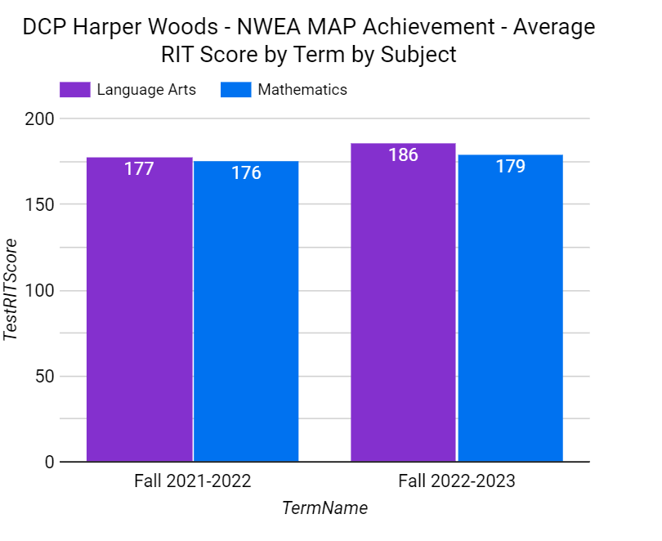

- IDENTIFY THE NUMBER AND PERCENT OF STUDENTS REPRESENTED BY PARENTS AT PARENT-TEACHER CONFERENCES

AT PARENT-TEACHER CONFERENCES
In 2022 - 2023, DCP had an average of 450 students represented by Parents at Parent-teacher Conferences.

We are so proud of the wonderful work families are doing here at DCP – Harper Woods. I would like to encourage all students and parents to continue to work hard. We appreciate the confidence parents have displayed entrusting the staff for their child's academic needs. As we move forward, the continued support and assistance of all stakeholders is greatly appreciated. We look forward to the continued partnership to help our students reach their highest potential. We are working extremely hard to increase achievement for our students.

Sincerely,

Erika Dietz

Erika Dietz
Principal

